**Report**

Main Menu for query selection:

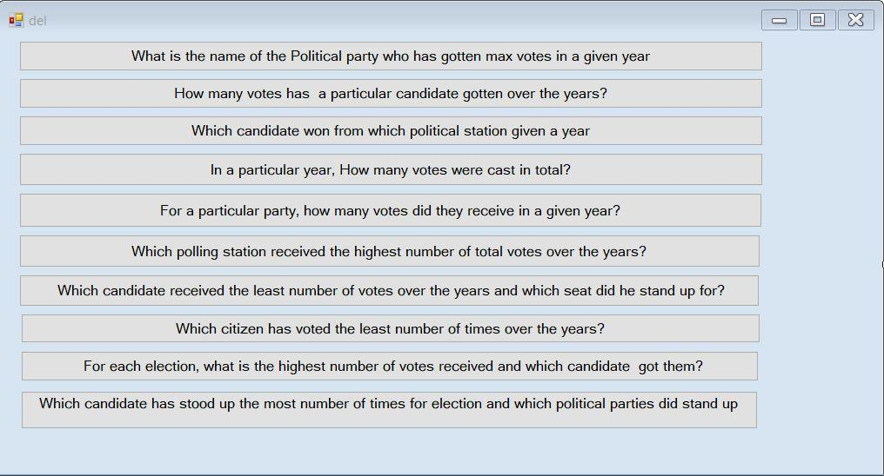

Query 1:

*we have 3 results here because these 3 got the max votes (i.e. these had the number of votes equal

To the max votes)

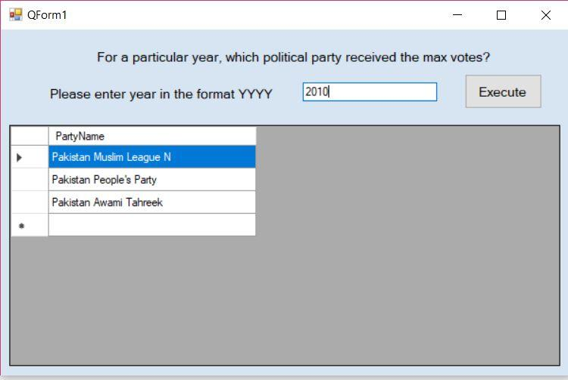

Query 2:

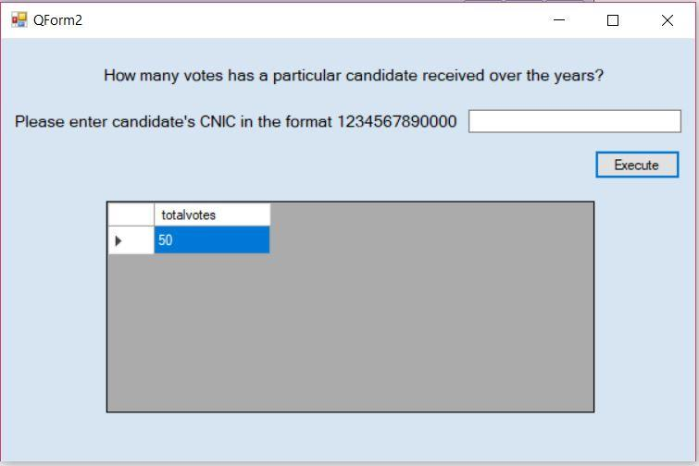

Query 3:

Takes year as input and gives the polling station IDs with the Candidate ID of the Candidate who won and the seat he\she was standing from.

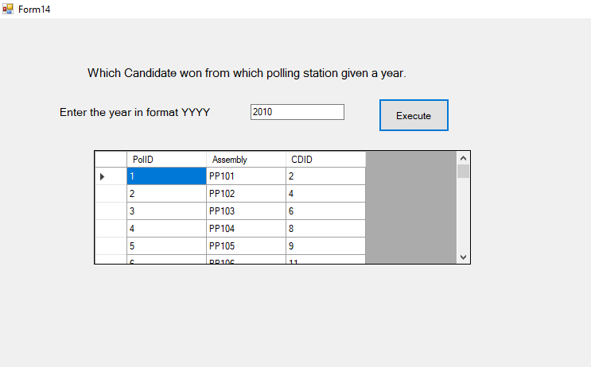

Query 4:

Takes the year of election as input and outputs the total votes casted in that year.

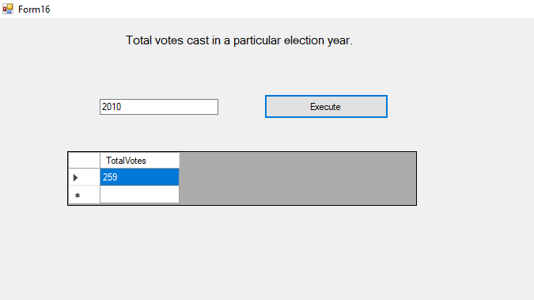

Query 5:

For this query user is required to enter the id for political party and the year for which he/she wants to view the total number of votes received by that party. The result shows the party name for id entered i.e Muslim League N and the total votes they received in 2010.

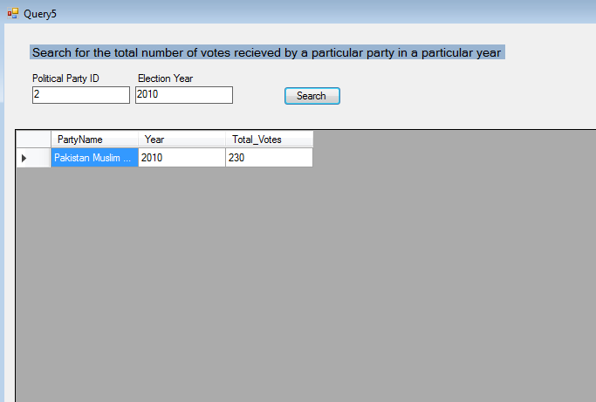

Query 6:

The result for this query shows all the polling stations that received maximum number of votes over the years.

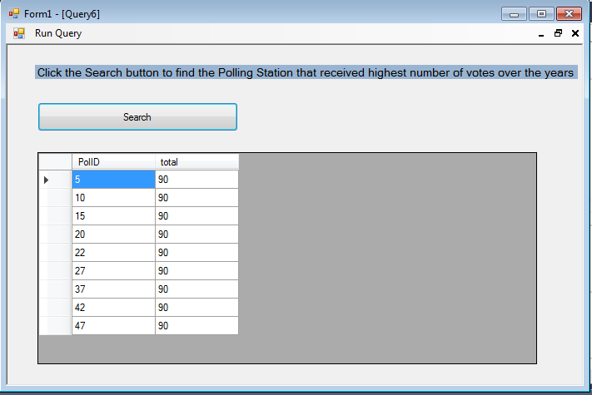

Query 7:

This Query views all the candidates’ id that received least amount of votes over the year and the seat for which they received these min votes.

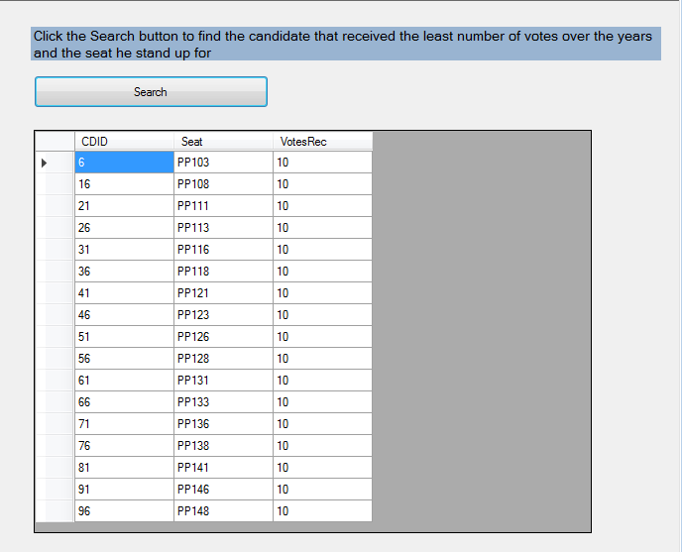

Query 8:

Outputs the names and genders of all the registered voters who casted the least number of votes over the years.

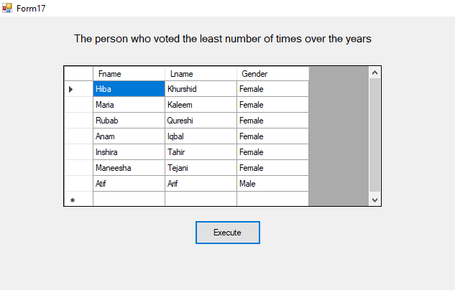

Query 9:

For each election, It outputs the election ID of the election, the candidates who received the highest number of votes in that election and the number of votes they received.

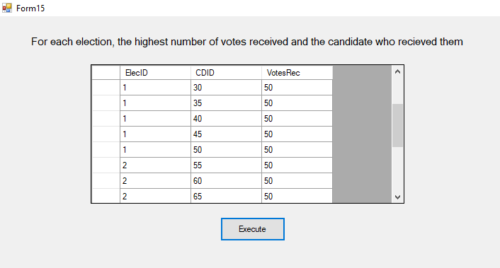

Query 10:

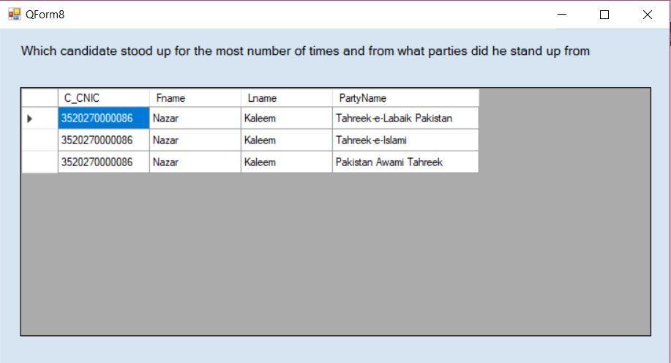

**Part 2: The back end**

Query 1: *eyear is the variable in which user enters his desired year

SELECT PartyName, SUM(VotesRec) As total

FROM election, voting, candidate, politicalparty

WHERE YEAR(election.Date)= eyear AND election.ElectionID=voting.ElecID AND candidate.PartyID=politicalparty.PartyID AND voting.CDID=candidate.CandidateID

GROUP BY PartyName

HAVING SUM(VotesRec) = ( SELECT SUM(VotesRec) As MaxVotesRec

FROM election, voting, candidate, politicalparty

WHERE YEAR(election.Date)= eyear AND election.ElectionID=voting.ElecID AND candidate.PartyID=politicalparty.PartyID AND voting.CDID=candidate.CandidateID

GROUP BY PartyName

ORDER BY MaxVotesRec DESC

LIMIT 1

);

Query 2: *ccnic is the variable in which user’s criteria is stored

SELECT PartyName, SUM(VotesRec) As total

FROM election, voting, candidate, politicalparty

WHERE YEAR(election.Date)= eyear AND election.ElectionID=voting.ElecID AND candidate.PartyID=politicalparty.PartyID AND voting.CDID=candidate.CandidateID

GROUP BY PartyName

HAVING SUM(VotesRec) = ( SELECT SUM(VotesRec) As MaxVotesRec

FROM election, voting, candidate, politicalparty

WHERE YEAR(election.Date)= eyear AND election.ElectionID=voting.ElecID AND candidate.PartyID=politicalparty.PartyID AND voting.CDID=candidate.CandidateID

GROUP BY PartyName

ORDER BY MaxVotesRec DESC

LIMIT 1

);

Query 3:

SELECT distinct p1.PolID, p1.Assembly, p1.CDID

FROM voting As p1

INNER JOIN

(SELECT PolID, election.ElectionID, Assembly, CDID, Fname, Lname, MAX(VotesRec) AS votes

FROM voting, candidate, registredvoters, election

WHERE YEAR(election.Date)=datee AND voting.ElecID=election.ElectionID AND voting.CDID=candidate.CandidateID AND candidate.C_CNIC=registredvoters.V_CNIC

GROUP BY PolID, Assembly) As p2

ON p1.VotesRec=p2.votes AND p1.PolID=p2.PolID AND p1.Assembly=p2.Assembly;

Query 4:

SELECT TotalVotes

FROM (SELECT SUM(VotesRec) AS TotalVotes, ElecID, YEAR(election.Date) AS dateee

FROM voting, election

WHERE election.ElectionID=voting.ElecID

GROUP BY dateee) AS P1

WHERE dateee=datee;

Query 5:

SELECT PartyName, Year(election.Date) AS Year, SUM(VotesRec) As Total_Votes

FROM election, voting, candidate, politicalparty

WHERE election.ElectionID=voting.ElecID AND candidate.PartyID=politicalparty.PartyID

AND voting.CDID=candidate.CandidateID

AND politicalparty.PartyID = '" & txtSearch1.Text & "' AND YEAR(election.Date)= '" & txtSearch2.Text & "'

GROUP BY PartyName;

Query 6:

SELECT PolID, SUM(VotesRec) As total

FROM voting

GROUP BY PolID

HAVING SUM(VotesRec) = ( SELECT SUM(VotesRec) As MaxVotesRec

FROM voting

GROUP BY PolID

ORDER BY MaxVotesRec DESC

LIMIT 1);

Query 7:

SELECT CDID, Assembly As Seat, VotesRec

FROM voting v1

where not exists (SELECT * FROM voting v2

WHERE v2.VotesRec < v1.VotesRec);

Query 8:

SELECT Fname, Lname, Gender

FROM voterrecords, registredvoters

WHERE registredvoters.V_CNIC=voterrecords.voter_CNIC

GROUP BY voterrecords.voter_CNIC

HAVING COUNT(voterrecords.ElectionID)=(

SELECT COUNT(voterrecords.ElectionID) AS Countt

FROM voterrecords

GROUP BY voter_CNIC

ORDER BY Countt DESC

LIMIT 1);

Query 9:

SELECT p1.ElecID, CDID, VotesRec

FROM voting AS p1

INNER JOIN

(SELECT voting.ElecID, MAX(VotesRec) AS votes

FROM voting, candidate, registredvoters

WHERE voting.CDID=candidate.CandidateID AND candidate.C_CNIC=registredvoters.V_CNIC

GROUP BY ElecID) AS p2

ON p1.VotesRec=p2.votes AND p1.ElecID=p2.ElecID;

Query 10:

SELECT C_CNIC, Fname, Lname, PartyName

FROM politicalparty, candidate, registredvoters

WHERE registredvoters.V_CNIC=candidate.C_CNIC AND politicalparty.PartyID=candidate.PartyID AND C_CNIC = (SELECT C_CNIC

FROM contestation, candidate, registredvoters, politicalparty

WHERE contestation.CDID=candidate.CandidateID AND candidate.C_CNIC=registredvoters.V_CNIC AND candidate.PartyID=politicalparty.PartyID

GROUP By C_CNIC

HAVING Count(candidateID) = ( SELECT COUNT(*) As counte

FROM contestation, candidate

WHERE contestation.CDID=candidate.CandidateID

GROUP By C_CNIC

ORDER By counte DESC

LIMIT 1

));